Task 1 - Create an ASP.NET MVC Web Application Project

Creating a New ASP.NET MVC Application Project

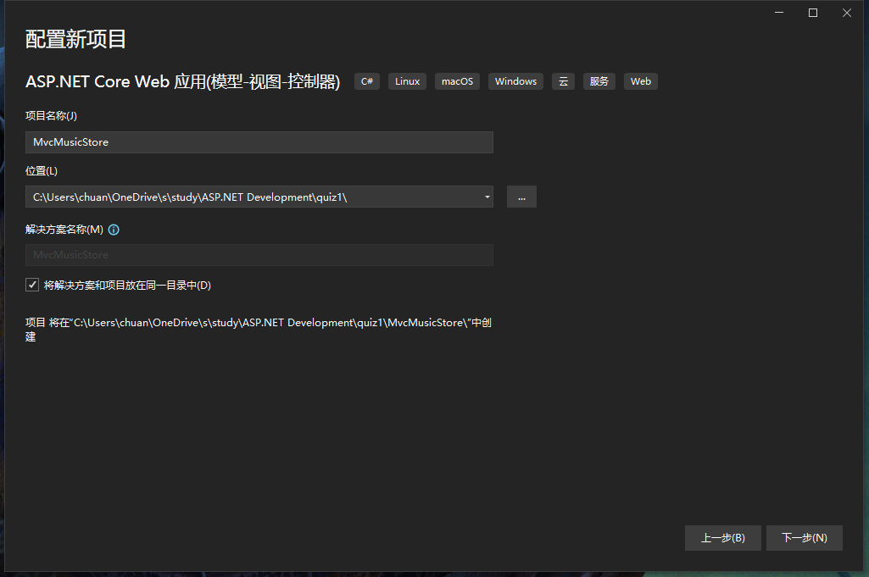

Setting up the database connection

We need to configure the project's database connection string so that the project can connect to the database

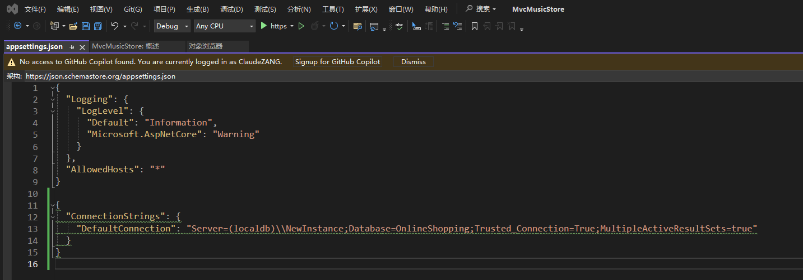

Installation of the Entity Framework Core

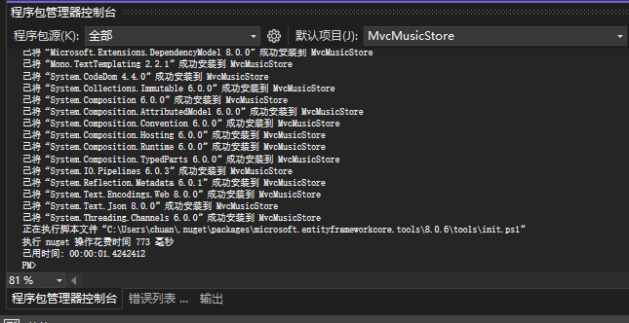

Create Model

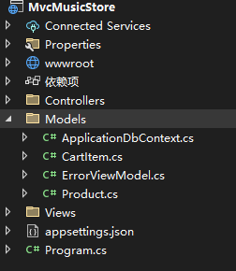

Add Startup.cs, update ApplicationDbContext, update appsettings.json, update Program.cs.

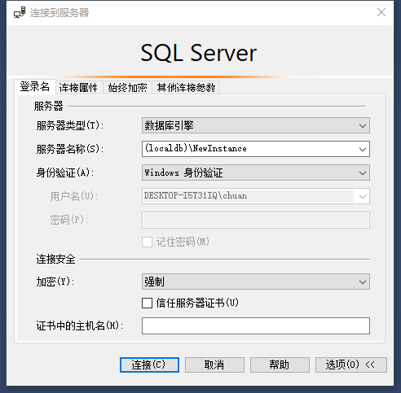

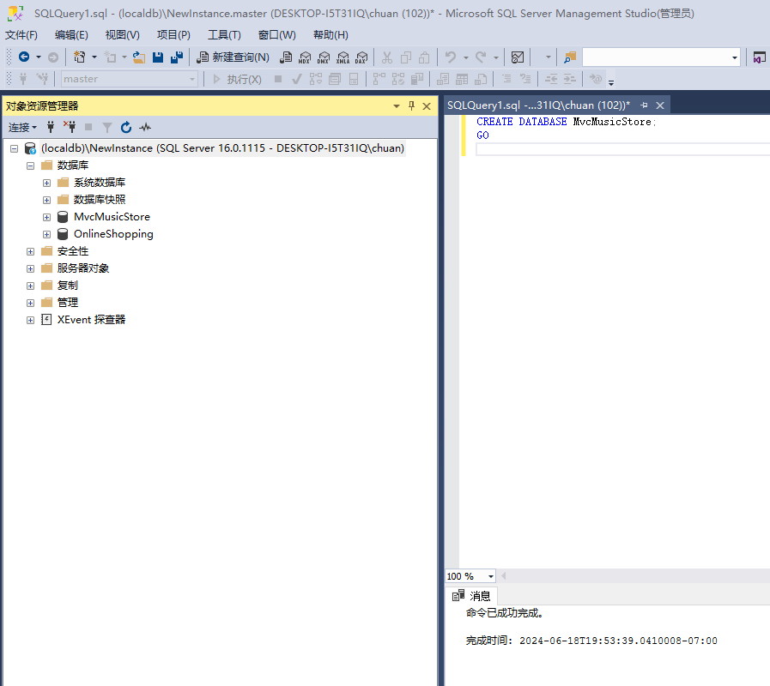

Run the migration command.

